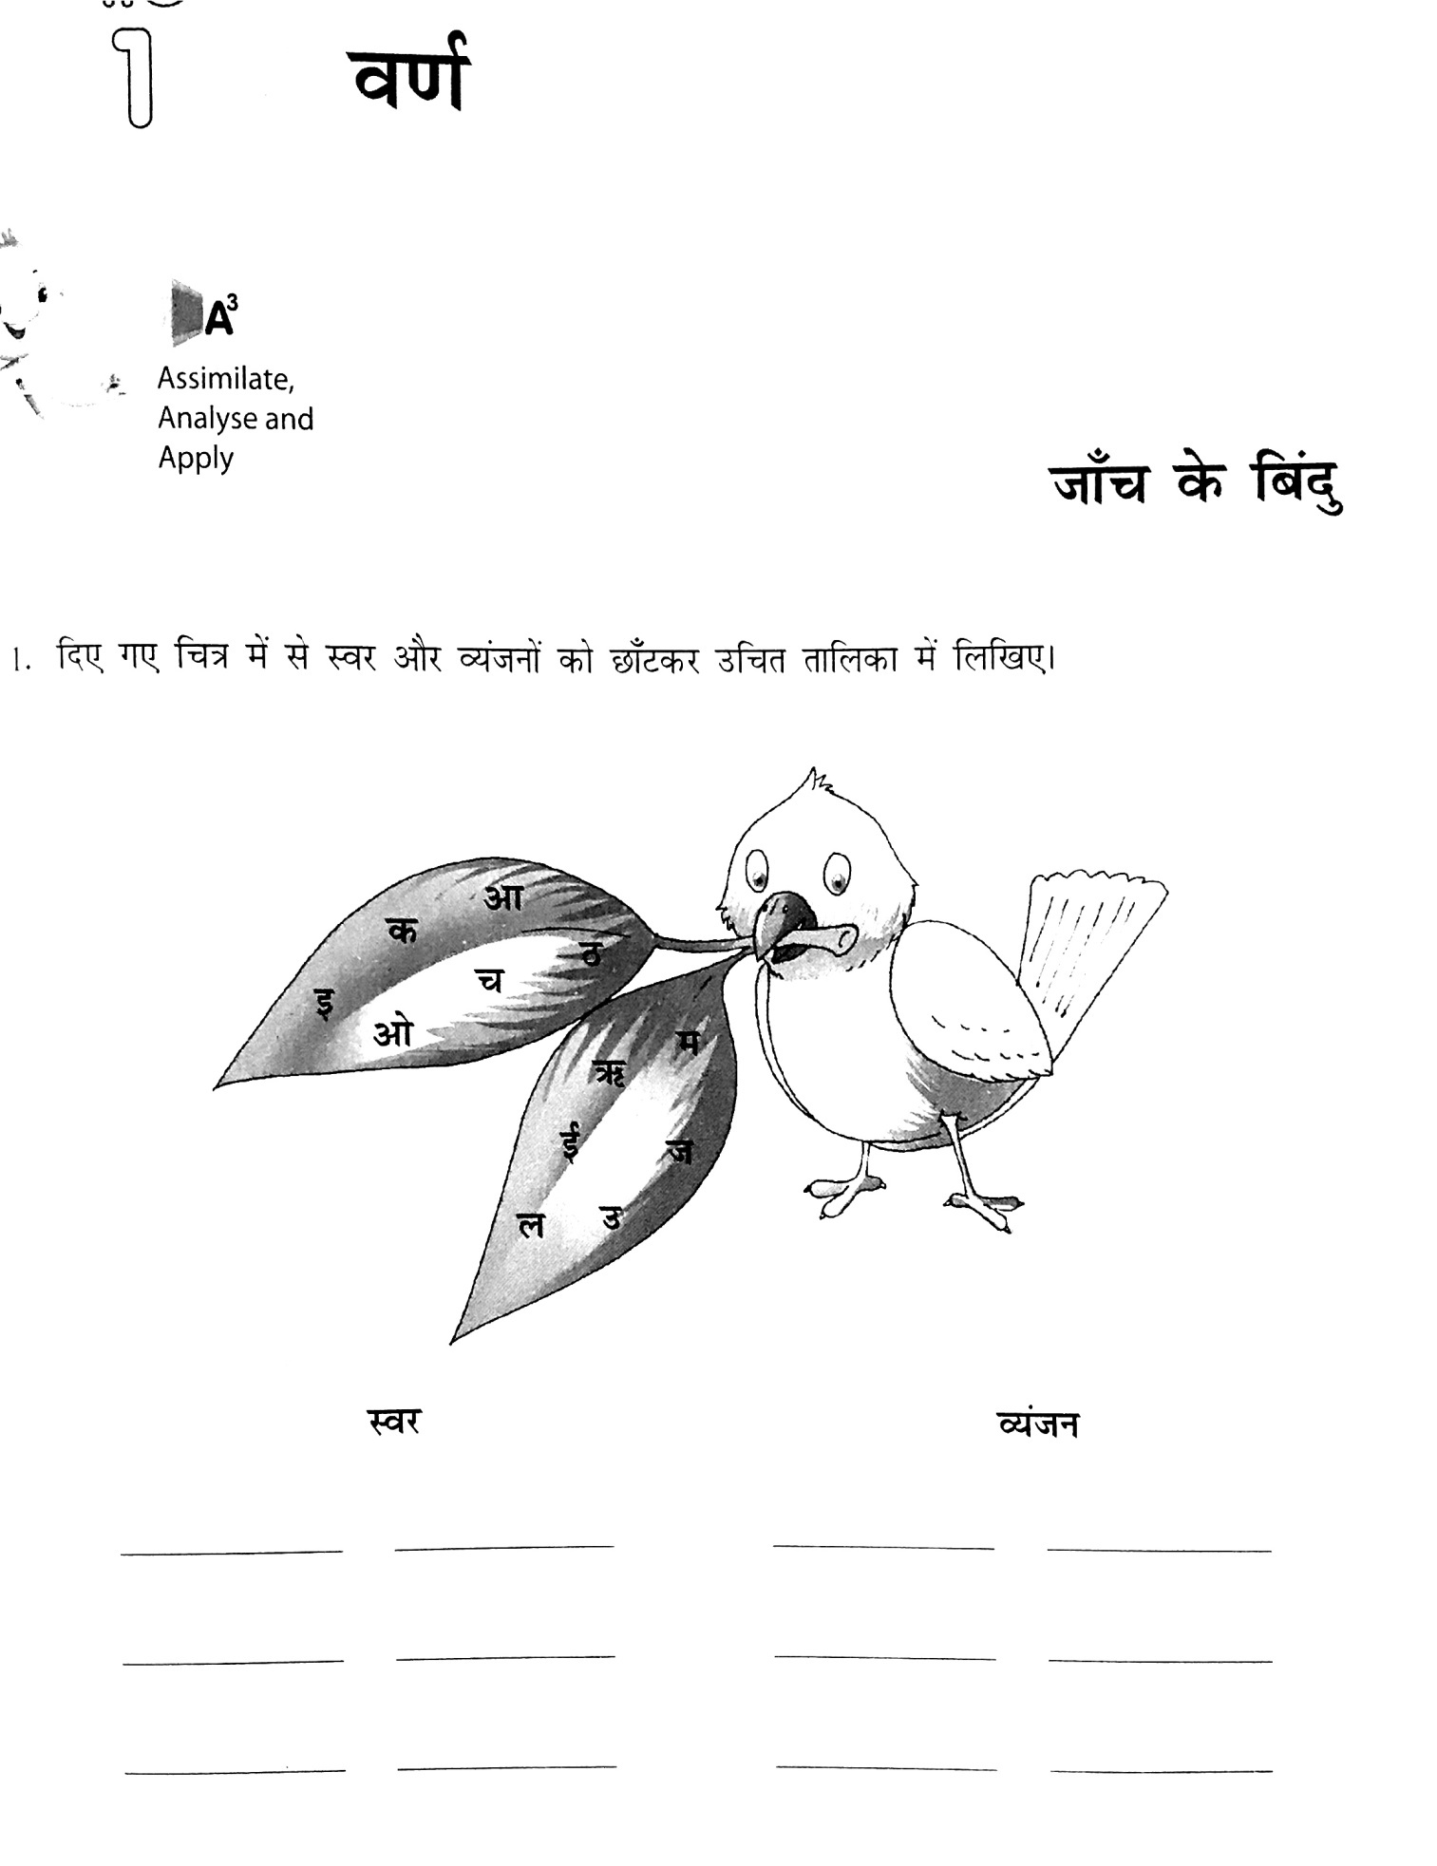
GRADE 7 (3L) GRAMMAR - (LESSON 1)

